

**Auto Complete Tasks**

### **Background**

Funnel has always offered the ability to set custom tasks on a prospect card to remind agents to complete a task by a certain date. These tasks can be added to a prospect manually by an agent, or can be added via Funnel’s marketing automation platform (ex: if the prospect hasn’t scheduled a tour after 2 days, add a task that says: “call prospect to schedule tour”). These tasks have always required manual completion by an agent - the agent marks the task as Completed in the CRM.

We now offer task types (email, SMS, or phone call) that are auto-completed when the corresponding communication type occurs. All of these options can be seen on the updated Add Task Modal on the prospect card.

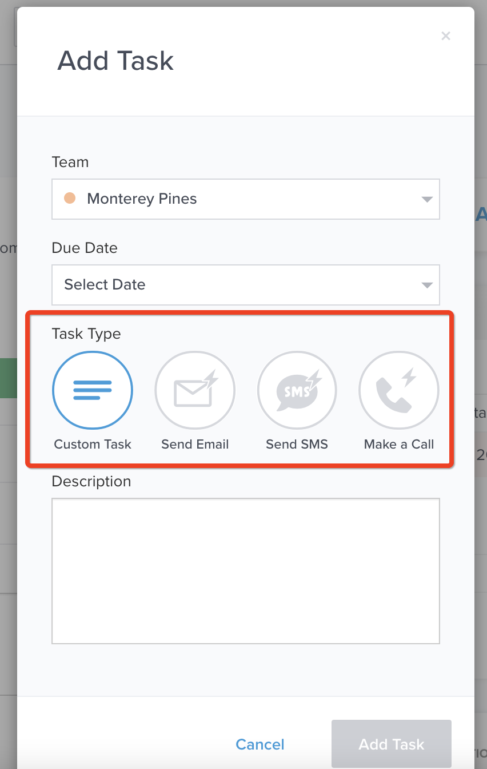

### **How it works**

Like custom tasks, the new auto-completed task types can be created manually or triggered utilizing automarketing rulesets.

Communication Tasks

To set up an **Email Task** to be auto-completed, select Send Email along with a due date on the Add Task modal:

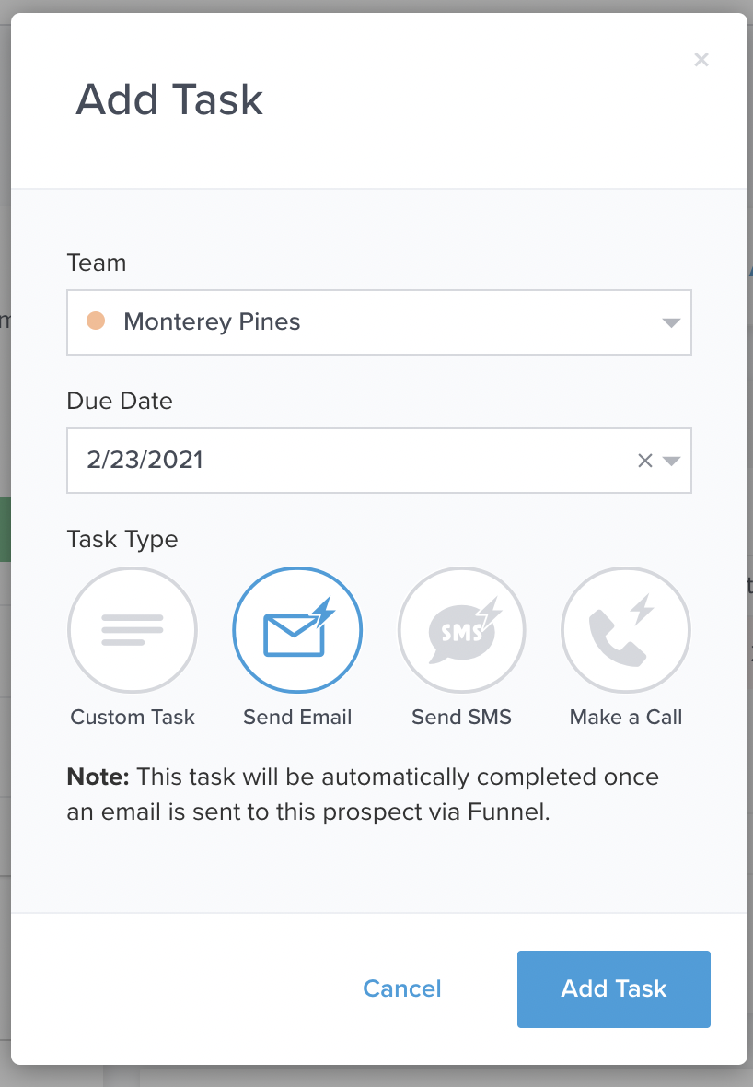

To set up an **SMS Task** to be auto-completed, select Send SMS along with a due date on the modal:

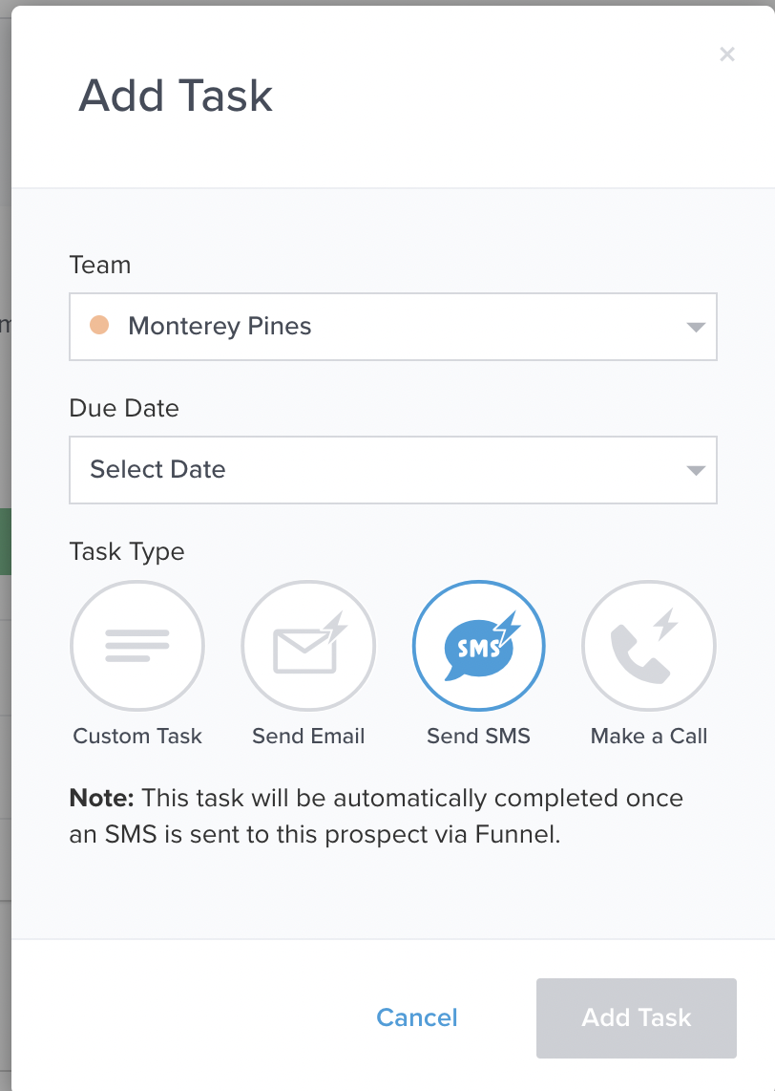

To set up an **Call Task** to be auto-completed, select Make a Call along with a due date on the modal:

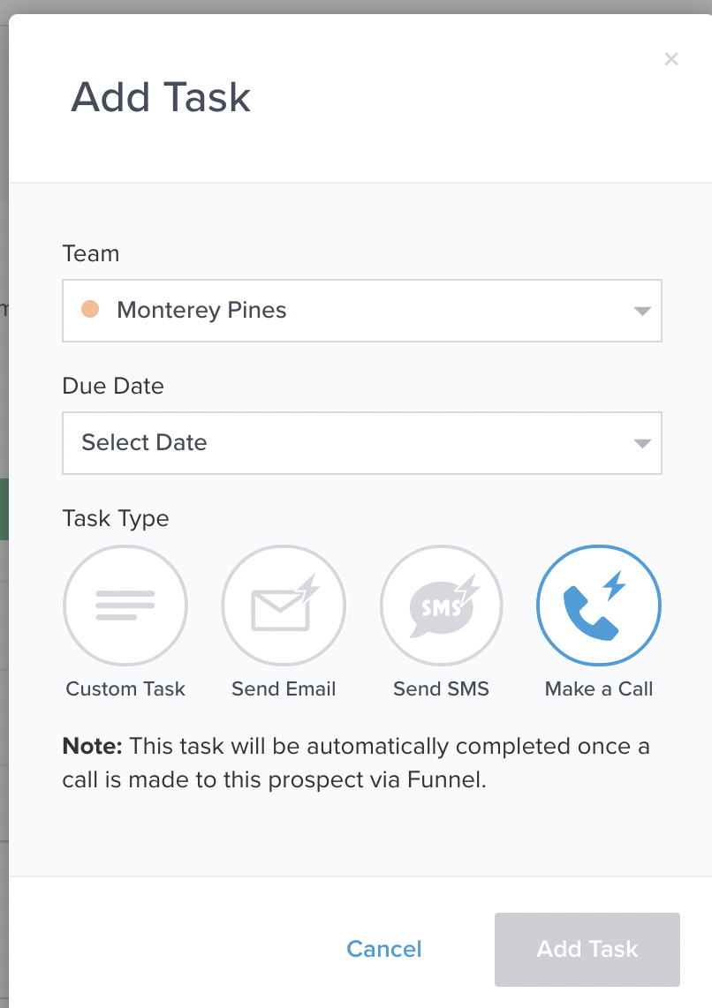

In all cases, click Add Task to complete the set-up. The task will appear in Tasks section of the prospect card:

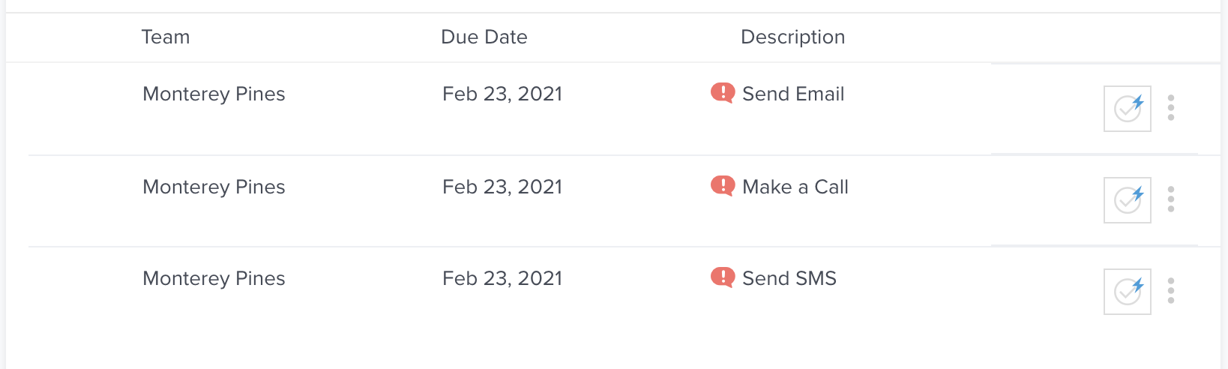

Any auto-completion task type will have a blue lightning bolt over the completion box. If you hover over the checkbox with the bolt, this message will appear with the appropriate communication type:

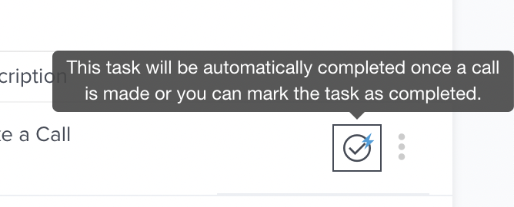

Custom Tasks

Users can still add any needed custom tasks in the Add Task modal:

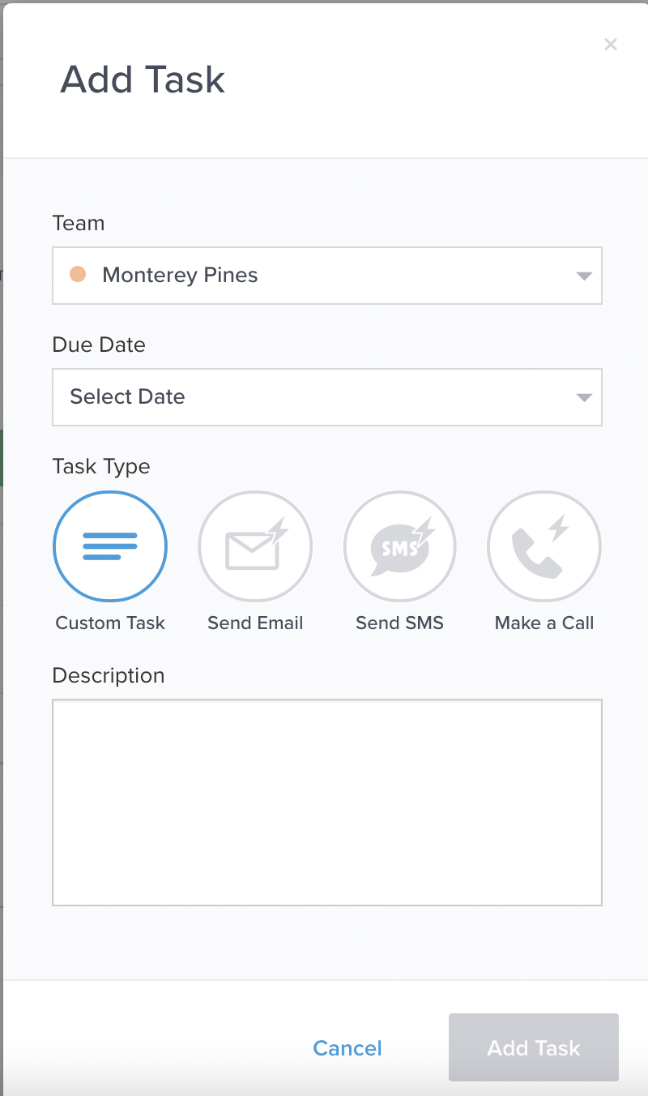

Users will need to add a description of the task in addition to the due date before a custom task can be created. Once it has been added, it will appear in the Tasks section of the prospect card sans the blue lightning bolt:

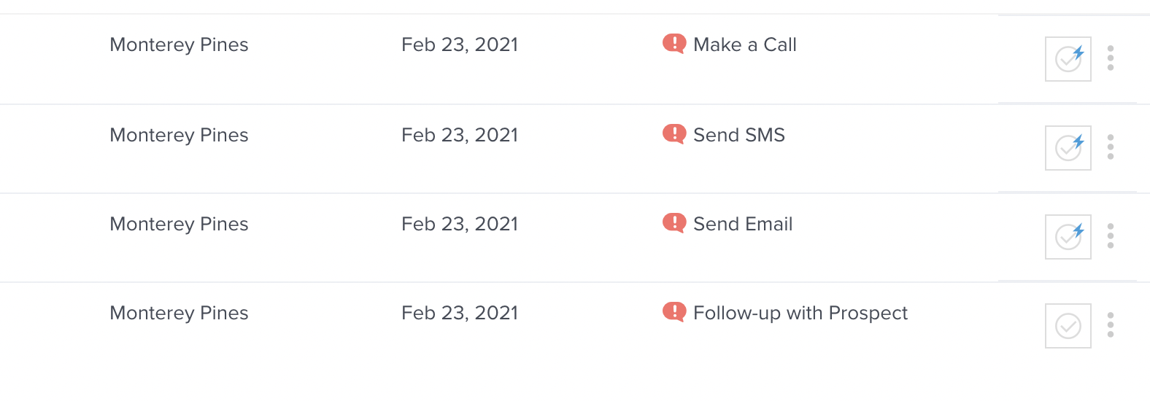

Custom tasks cannot be automatically completed, so it will be necessary for users to manually mark the applicable task completed.

Auto-Completing Tasks

To auto-complete the tasks, an agent from the associated team must place the associated outbound communication type (call, email, or SMS). The task completion will be attributed to the agent that initiated the communication and thus completed the task.

*Note: Bulk messages and Automated messages will* ***not*** *complete these tasks.*

To complete an **Email Task**, an agent will need to manually send an email to the prospect. Once the email has been sent, the task will be completed, disappear from the Tasks section, and will appear as completed on the timeline:

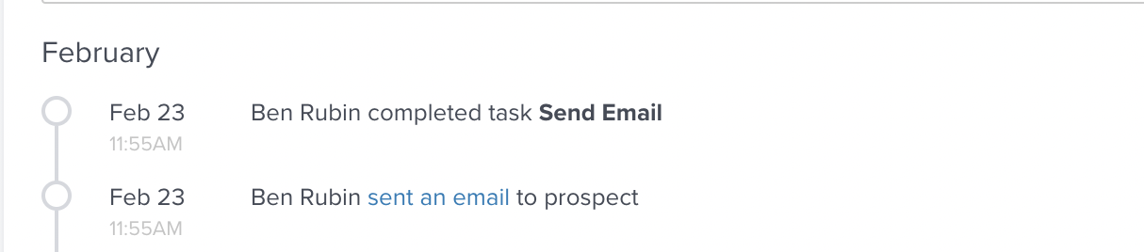

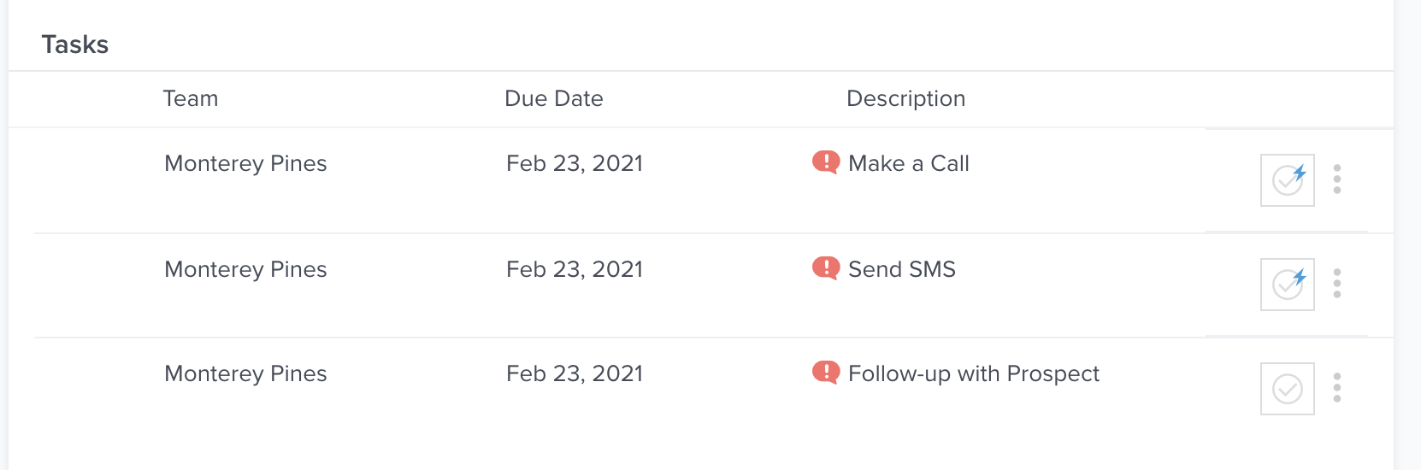

This action will not complete a Call Task, SMS Task, or Custom Task associated with this team and prospect.

To complete a **SMS Task**, an agent will need to manually send a SMS message to the prospect. Once the SMS message has been sent, the task will be completed, disappear from the Tasks section, and will appear as completed on the timeline:



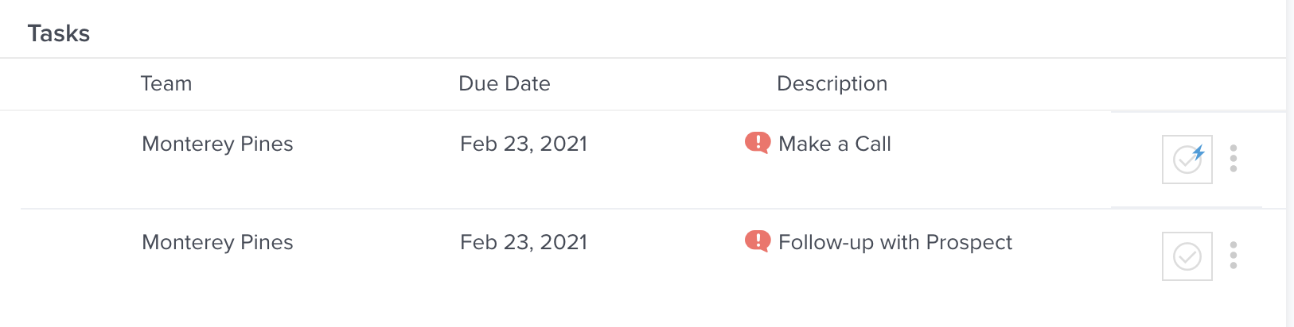

This action will not complete a Call Task, Email Task, or Custom Task associated with this team and prospect.

To complete a **Call Task**, an agent will need to make an outbound call to the prospect. Once the call has been completed, the task will be completed, disappear from the Tasks section, and will appear as completed on the timeline:

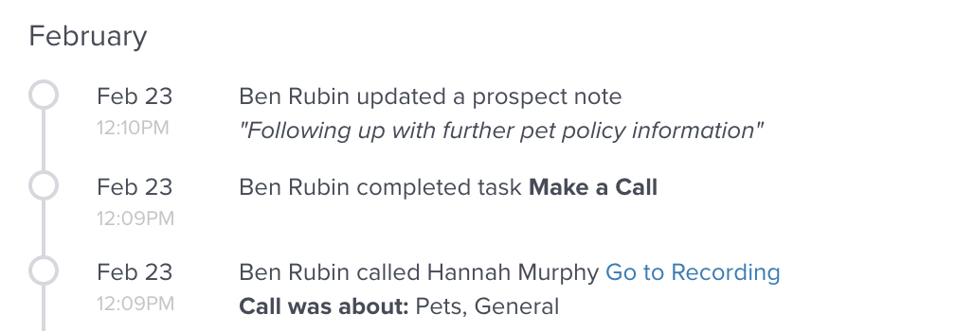

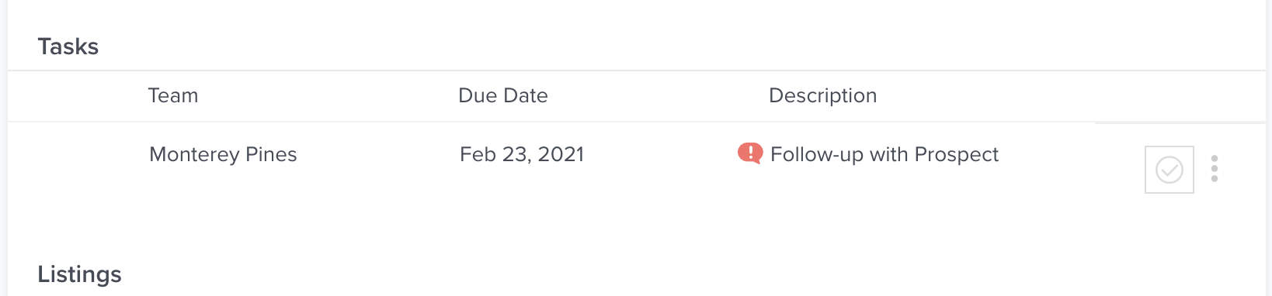

An outbound call will complete a Call Task even if a prospect doesn’t answer the call. This action will not complete an Email Task, SMS Task, or Custom Task associated with this team and prospect.

### **FAQs**

*Do I have to pick a task type when adding a new task?*

Yes, any new task will require you to select a task type. However, you can always choose the Custom Task type to set up a task you don’t wish to be auto-completed.

*Can the Auto-completion tasks be generated automatically?*

Yes, triggers can be set up to generate these tasks for prospects that fit certain criteria, such as not communicating with the community for a certain number of days.