**RENTCafé Kiosk Setup**

1. Unpack your tablet and plug in to charge the device.
2. Unpack the stand and install the smaller device clamp.
3. Press and hold the power button until the Lenovo Logo appears
4. At the Welcome screen select “**LET’S GO**”

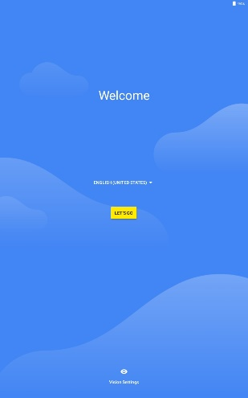

1. Select “**Set up as new**”

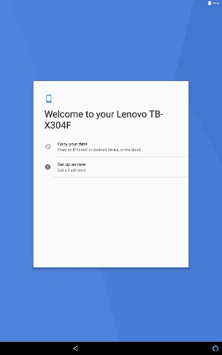

1. Get connected – Select “**Essex-2**”

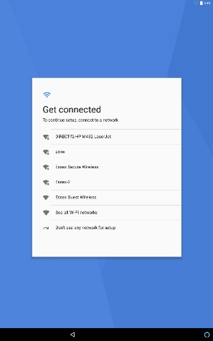

1. Enter password: **\*\3pRvV6+d**
2. Select “**Connect**” (*you will see Checking for updates…. Checking Info…..)*

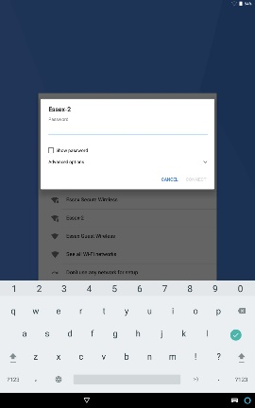

1. Sign in:  **afw#meraki**
2. Select  “**Next”** (*you will see Checking Info….*)

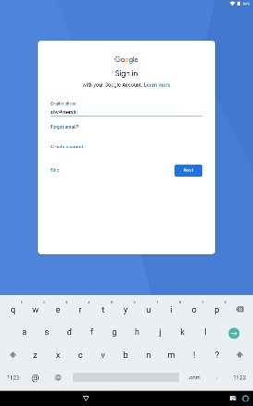

1. Android Enterprise – Meraki System Manager: Select “**INSTALL**”

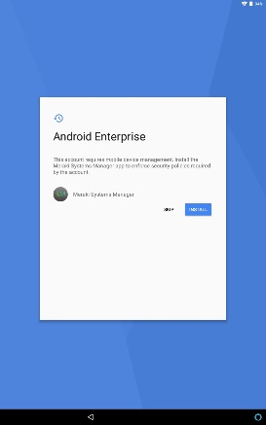

1. Meraki SM:  Select “**INSTALL**”

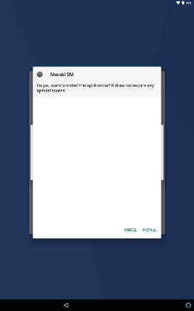

1. Setup up Work Device:  Select “**NEXT**”

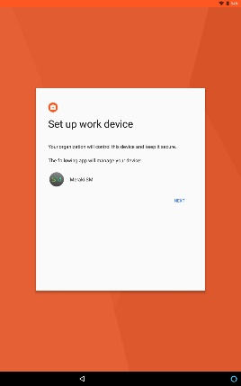

1. Your admin has the ability……: Check “**I CONSENT**”, then select “**OK**”

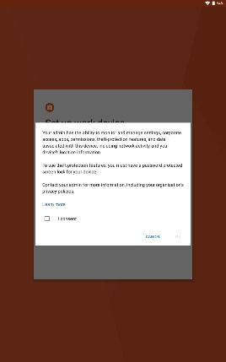

1. Accelerated Location:  Check “**Location consent**”, then select “**NEXT**”

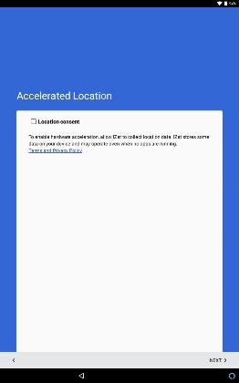

1. Select “**FINISH**”

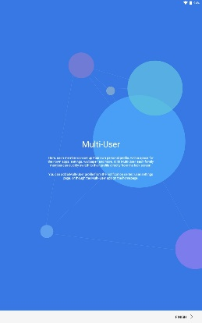

1. If “Google Contacts Sync has stopped” comes up – Select “**Close app**”

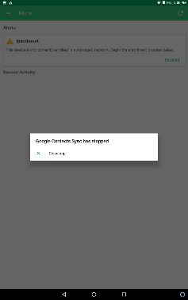

1. Enrollment: Select “**ENROLL**”

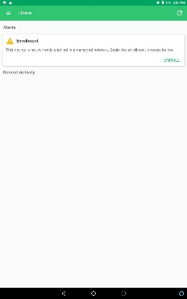

1. Tap on the line (to enable the key pad to pop up) Type:  **110-158-2104**
2. Select “**ENROLL THIS DEVICE**”

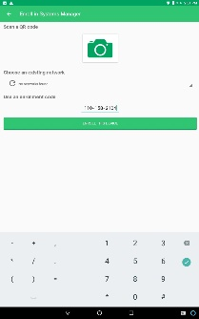

1. Wait 3 minutes. When the device is ready, the following screen will appear (refer to step 22).
2. It may ask you to do a system update.  If so, Select “**Yes**” – the system will update and reboot and come back to this page.

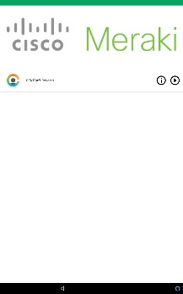

1. At this screen select the **RENTCafe Resident** icon and Log-In.

