Hi Everyone – Thank you for taking the time to join our December Quarterly Maintenance Department Call! Below are a few highlights of the things we covered during our time.

*Make-Ready Day Movement:*

Current month’s year-over-year move-out to rent ready days:

* 7.6 in 2018 compared to 7.3 days in 2019
* It’s a tight race, but NorCal maintained the lead at 7.1 days across 647 move-ins.

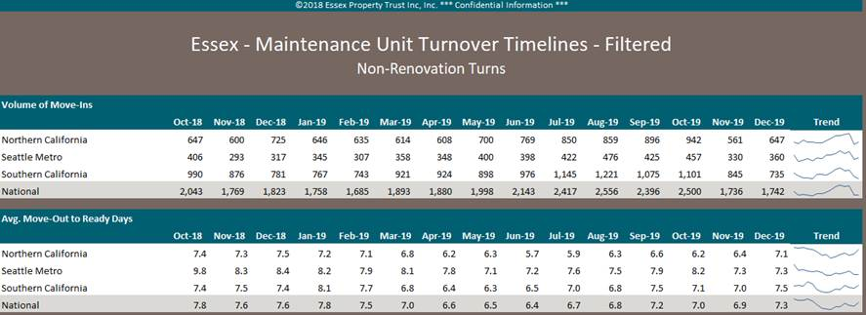

Below is our annual performance for the prior 4 years. Congrats to the NorCal team for taking 2019!

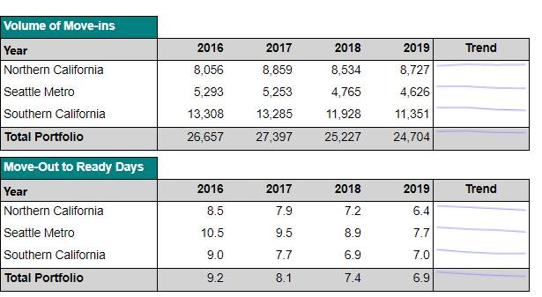

Below are our top 20 make-ready performers in 2019, CONGRATS!

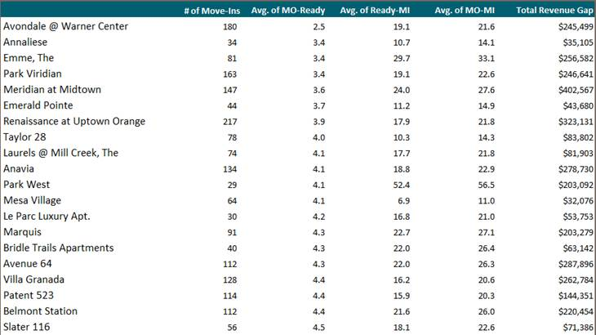

*New Make Ready Report Demo*

* We stepped through the recently released report which allows you to see your make-ready days by the date they were made ready, not the move-in date. Give it a shot yourselves and see how your current efforts are performing.

Quarterly Property Safety Inspection for 2019 Due

* In following with our Quarterly/Monthly Safety inspections, December should be complete.
* A new version of this file has been refreshed in the common drive for 2020
* Reminder that one of these walks must be completed in partnership with your RPM.
* Don’t be afraid to identify issues, it doesn’t have to all be green. Issues will come up and it’s important to document them
  + 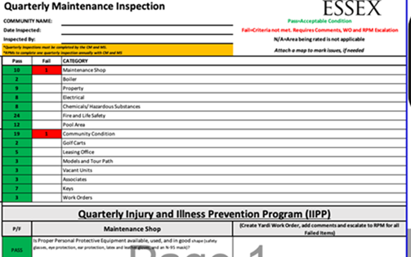

AMG Training Completion Report

* We stepped through some background on our recently released policy training. We’re currently at 90% for completion. If you, or your team haven’t completed this, please make it a priority.
* We have since assigned this training to the ACM and Project Manager roles.

***PILOTS:***

* *SightPlan*
* *This is a new program that we’re using to manage all of our work orders and inspections. Danny Viera (MS Park Viridian and Anavia) shared his experience so far with the program and how it’s made a meaningful impact to his team*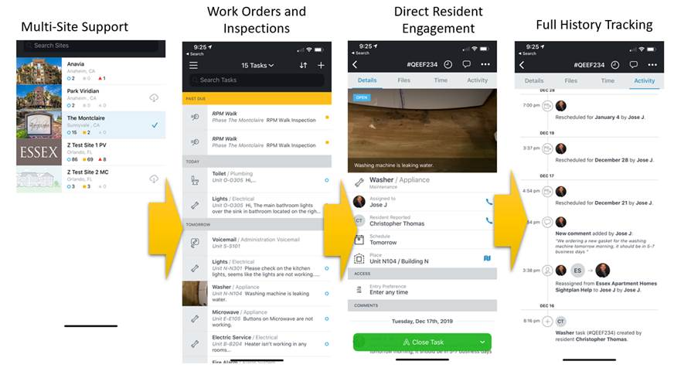

* Resident Videos:
  + The 5 videos we’ve produced are now live on the Resident Portal
  + Again, thank you to Adrian Aguilar, Gonzalo Gomez, Charles Mishlof and Andy Goodwin for being our actors.
  + We plan to produce several more in 2020.
    - 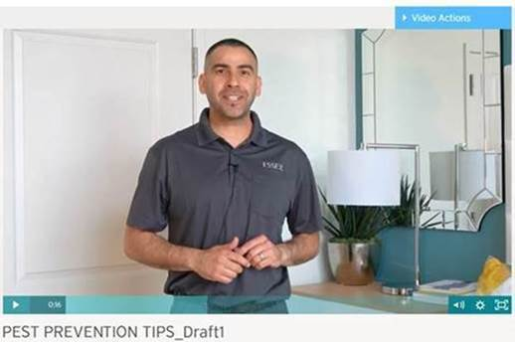
    - <https://www.essexapartmenthomes.com/careers/jobs/job?jobId=6220>

Thank you for taking the time out of your busy schedules to join the call, and be sure to join our next call!

Kind Regards,

Steven Steele

Director, Maintenance Operations

