Prior to posting on Craigslist…
Login to your non-Essex Craigslist email account (Gmail, Yahoo, Hotmail, etc.)

PAUSE  Before you post | Post 3-4 times per day  Accurate contact information  Unique and specific content for each ad  Select images from Photo Shelter  Ensure disclaimers are included
Minimum Posting Requirements for your Craigslist Posts
Contact Information
- Tracking phone number ONLY
- Community Leasing Office Address
- Community Website link (non-clickable)

Confirm the phrase at the bottom of your description.
“Pricing and availability is subject to change” And “Equal Housing Opportunity”

Use photos from Essex Image Library on Buzz. Include an exterior, 2 interiors, amenity, and floorplan. Need help downloading images see the Marketing Photography page on Buzz for the guide.

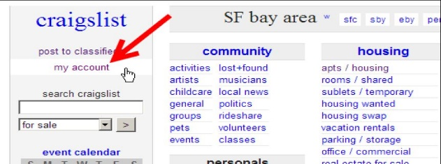
Need your Craigslist Tracking Number? Buzz -> Marketing -> Internet Marketing Resources - > Craigslist - > Select- >New Ad Source Tracking Numbers - Craigslist & Outreach Collateral
Need your floor plan images? Common Drive -> Marketing – Property Projects -> Community Name -> Floor Plans -> Select 2015 Floor Plans -> use the JPG version only

    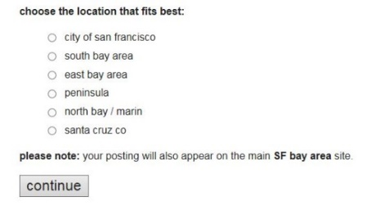  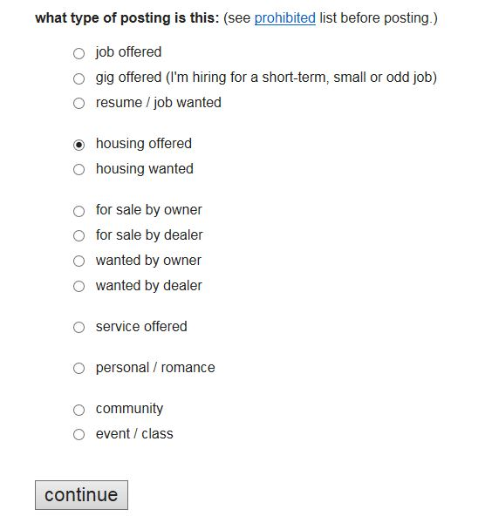  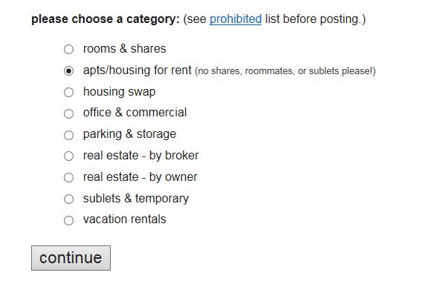    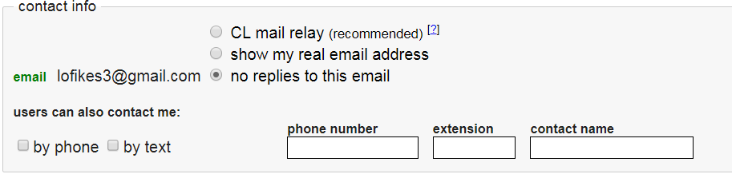  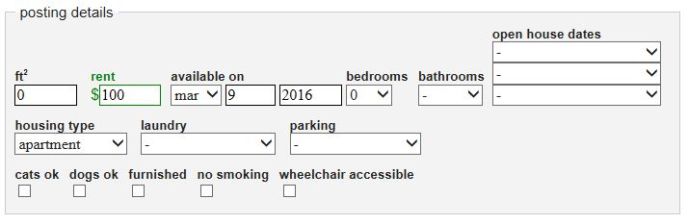  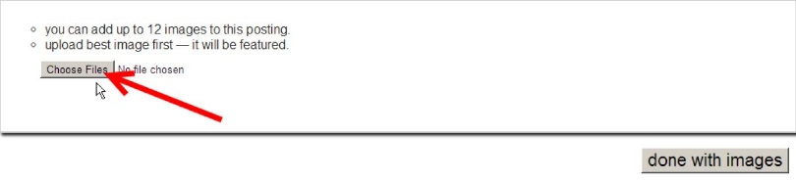  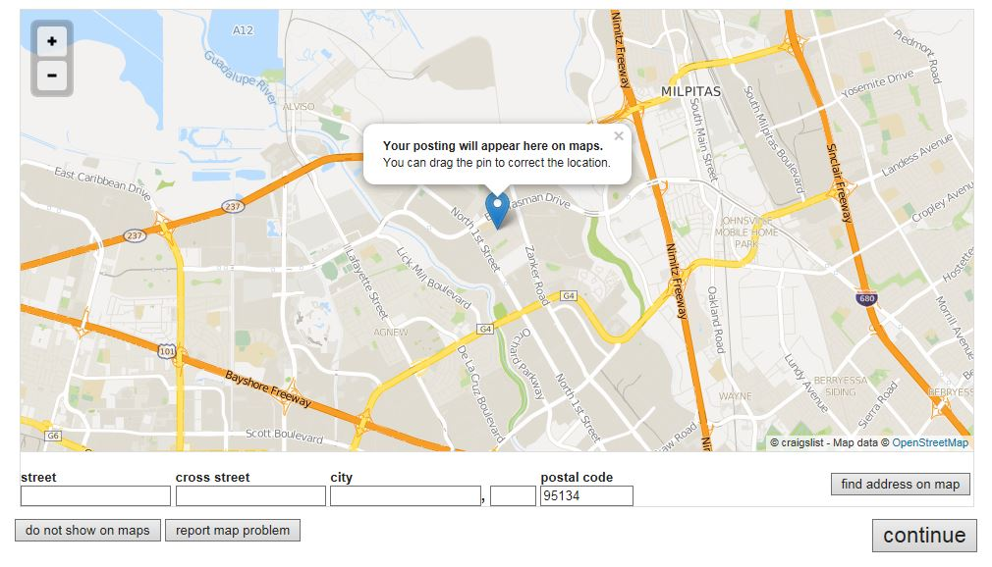   |  | Login to Craigslist (my account) – http://www.craigslist.org using your non-Essex email and password for your Community  Post to Classifieds to create a new ad.  - Type of posting: housing offered  - Category: apts/housing for rent  - Location: “select your area”  Verify your username email is displayed and enter your Craigslist tracking phone number, select “no replies to this email.”  Fill out the rest of the Ad with the correct information (title, pricing, location, etc.). Paste or type updated PROPERTY DESCRIPTION to the body of the craigslist post and click on “continue” when you’re done. Fill out all the boxes necessary. (sq ft., rent amount, available date, bedrooms, bathrooms, etc.)  Preview your Craigslist ad and click on the “publish” button to complete the process.  Happy Posting!
Post Ad on Craigslist

