**Maintenance Uniform Ordering Instructions   
Ordering opens: 11/6/19**

Please follow the following guidelines when ordering your Maintenance Uniforms.

The ICO Store will be open starting on **11/6/19 and will close 11/22/19.**

# How to Order Apparel

The Community Manager of each property will be responsible for ordering apparel for the team using **ESX2 Store ID**. Each property account will be given $380 per maintenance associate.

ASSOCIATE INSTRUCTIONS:

STEP 1:Review the Maintenance Apparel catalog located on Buzz to see options available for pants, shirts, jackets, and hats.

STEP 2: Choose which color scheme you will be selecting for your community (one scheme per community).

**COLOR SCHEME # 1** (Navy Blue Shirts/Grey Pants)

**COLOR SCHEME # 2** (Grey Shirts/Navy Blue Pants)

Mark selections on the appropriate order form. Each associate is allowed the following:

6 -Shirts (may be grey or navy)

6 -Pants (may be grey or navy)

1 - (3-in-1) jacket **or** 1 Light jacket and 1 vest (if you choose the 3-in-1 Jacket you may not order a vest)

2- Hats (grey or navy)

STEP 3: Immediately submit your order form to your Community Manager, who will place one order for the property.

Please note: You must choose from either color scheme #1 or #2 as outlined previously.

COMMUNITY MANAGER INSTRUCTIONS:

STEP 1: Collect all order forms from each Maintenance associate. Ensure each associate has the appropriate color scheme and clothing count.

STEP 2: Log into myicostore.com using the property email address. Do not use your personal career apparel account.

**Here's how to access:**

* Visit 'MYICOSTORE.COM'
* Username is your property email address.
  + (For example: stationparkgreen@essex.com)
* Your temporary password is 'changeme'.
  + Once the password has been changed, please use the new one for future orders.
* Store ID ‘**ESX2**’.
* Click ‘Go’.
* Please use coupon code "**essex**" to receive free shipping on orders of $250 and over.

STEP 3: The property account will have the funds loaded for the entire property ($380 per associate)

STEP 4: Place one order for the entire maintenance team starting on 11/6/19. Your deadline is 11/22/19.

STEP 5: Keep the individual order forms. You will need them to distribute the uniforms upon delivery.

If an associate is hired after the annual order is placed, please refer to BUZZ and follow the same steps as you would for a new administrative associate, however, please use the property name and the property email address instead of the new associate’s name and email address.

# Need Help? For program guideline questions please contact us at [E-Apparel@essex.com](mailto:E-Apparel@essex.com)

Complete your order by November 13th and you will receive a FREE Essex hat!

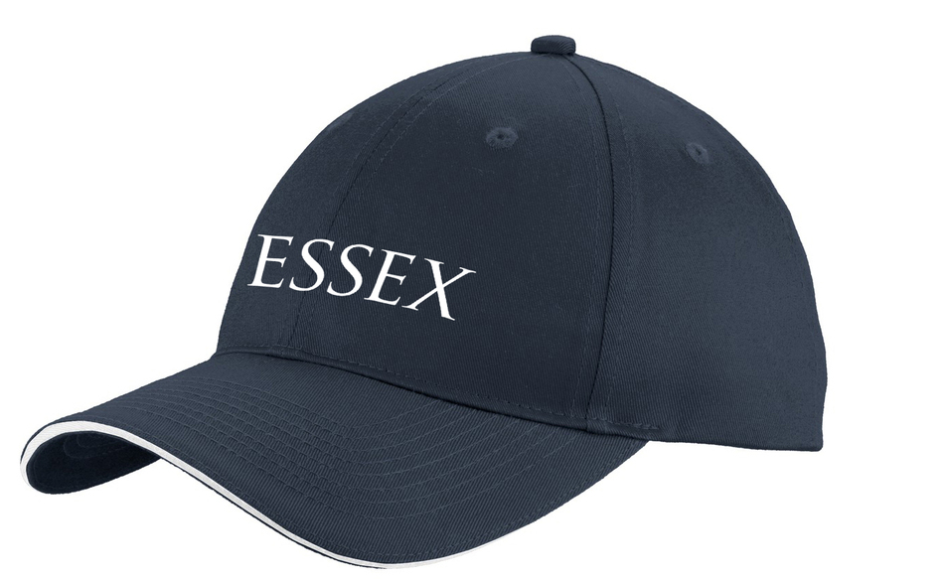

**Early bird catches a FREE cap!**