**Job Aid: Craigslist and Flyer Process Change**

As noted in the 11/29 E-Hour, leasing office associates will need to update all current Craigslist Ad templates and any outreach fliers that show phone numbers to support Essex’s transition to the Knoah Contact Center.

Please complete the below changes by EOD Wednesday, December 13.

Contact [Marketing@essex.com](mailto:Marketing@essex.com) with any questions you may have.

**OUTREACH AND RESIDENT REFERRAL FLYERS**

* Outreach collateral is collateral that is used for publicity/outreach purposes and does not include pocket brochures, site maps, and floorplans.
* Most outreach fliers do not contain phone numbers. However, in the event they do for your community, these phone numbers will need to be changed to the new Knoah-issued phone number.

**Step 1:** Inventory any existing outreach collateral

**Step 2:** Check to see of a phone number is listed on the collateral

**Step 3:** Reference the attached spreadsheet, “New Ad Source Tracking Numbers - Craigslist & Outreach” Collateral” for your community’s corresponding ad source tracking numbers.

**Step 4:** Replace LevelOne tracking numbers with Knoah tracking numbers by either updating your templates or re-ordering from the Benson Home Store.

**CRAIGSLIST**

**Step 1: Template Clean-up**

* In your Craigslist account, remove ads that are:
  + Stale/old ads that your team no longer uses.
  + Repetitive
  + Duplicates
* Aim for no more than 25 unique Craigslist ad templates.
  + Each should be unique and feature different selling propositions.
  + For example, one can be specific about features or amenities; another can be about location, specific floor plans, etc.

*Example of a Craigslist account page*

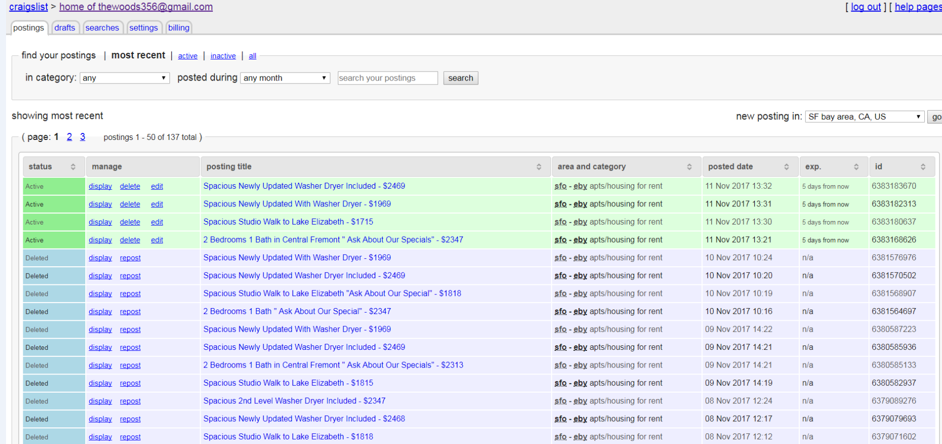

**Step 2: Replace Level One Tracking Numbers with Knoah Tracking Numbers**

Update all ad source tracking numbers indicated in Craigslist ad templates

Reference the attached spreadsheet, “New Ad Source Tracking Numbers - Craigslist & Outreach Collateral” for your community’s corresponding ad source tracking numbers.

*In your Craigslist ad, this is where the ad source number should be located*

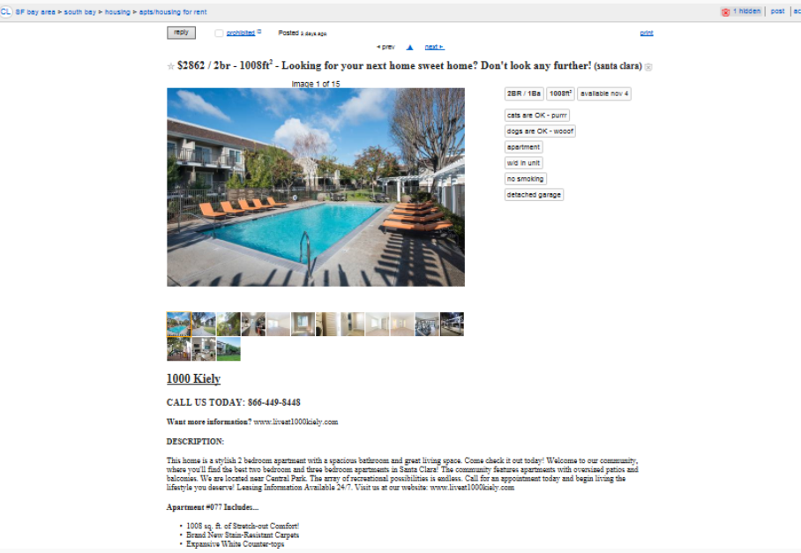

**Step 3: Select “No Replies to this Email”**

**Due to negligible traffic, we are no longer supporting emails for Craigslist:**

* In the “Contact Info” step of creating a Craigslist ad, select “no replies to this email.”
  + See screenshot below.
* If your community has a NewHome1 email forwarding address set up, you will need to update that as well.
* There is no need to include an email address in the body of your CL post.
* Other than the above, complete the remaining Craigslist ad information as usual.

