Excluding BMR units
If you have income- or age-based housing programs (such as below market rate, affordable housing, Section 8 and senior housing), you need to flag these units in Yardi so they do not display on your community website or ILS’s.
- Within Yardi, go to the Community Manager or Assistant Manager Dashboard. From the side menu on the left, Unit Pricing→Update Portal Unit Display→Update Unit Display
- Enter your community at the top of the screen.
- If your income-/age-based units are always the same units, choose the “All” option under “Show Units.” Click “Preview.” (If your units do not remain the same, skip to step 4 below.)
You will see a list of all units at your community. Click the “Do not show” checkbox next to your income-/age-based units. Click “Save” when complete. You will not have to return to this screen and complete this setup again unless these units change.
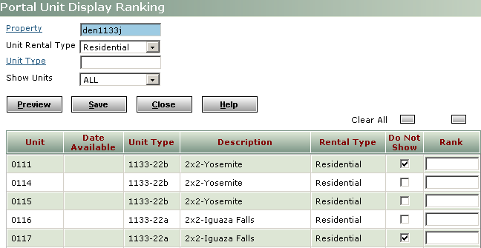
- If your income-/age-based units vary based on availability/applicant preference, choose the “Avail. only” option for “Show Units.” Click “Preview.” This will display a list of available units at your community.
Choose the “Do not show” checkbox for units are currently reserved for applicants with that meet specific income- or age-based criteria. Click “Save” when complete.
You must continue to update this list every time a BMR unit becomes available.

