**Essex:** **How to Access Closing The Loop Tasks and Reassign back to Linnel Taylor.**

**There are 3 options:**

1. Email Alert with the Closing the Loop Task

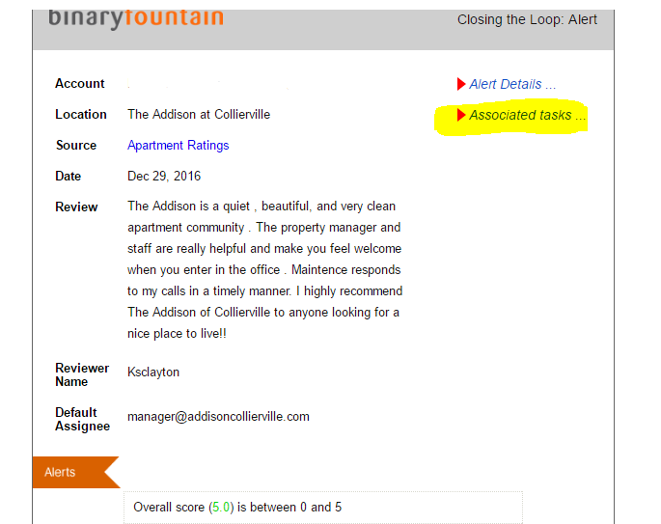

1. Click into the review on the home page and select “Respond” on the top Right –

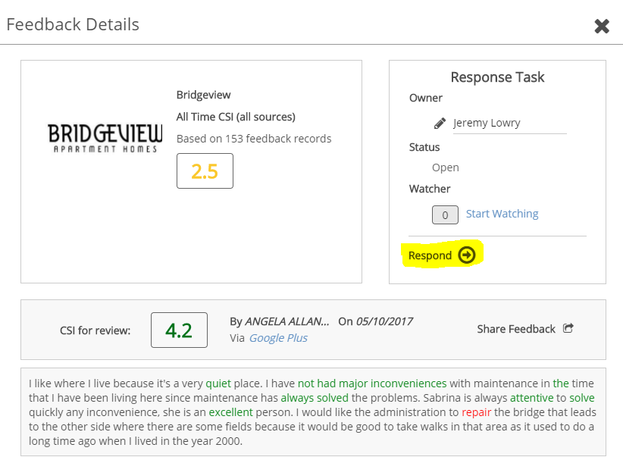

1. Click on Action Tab at the top, **Closing the Loop**, and review all open reviews. 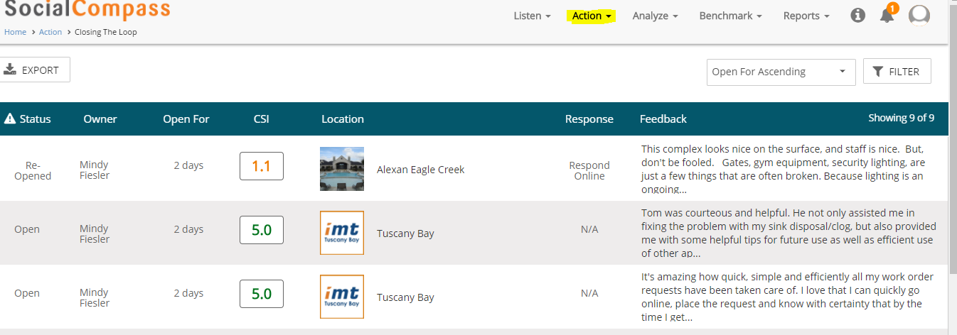

**How to reassign a task to Linnell Taylor:**

Linnell Taylor will be the first owner of the task. They will review the task details, and within **closing the loop**, they will click on the owner name and type in the manager’s name of the property:

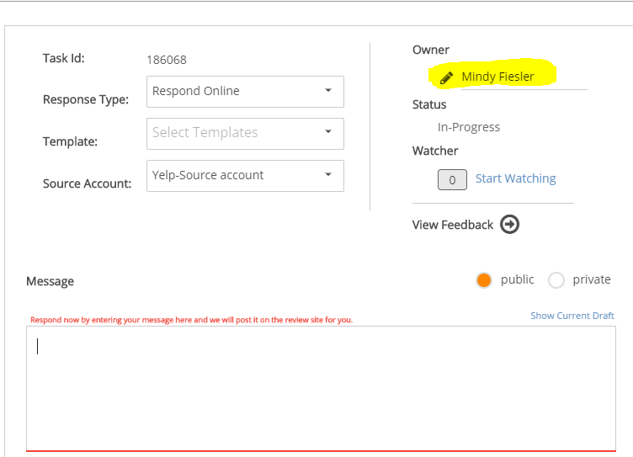

They will then type their message to the manager and hit submit. Now the manager is the owner of the task, will get the email with the notes, and can log in and follow the same process to reassign the task back to Linnell Taylor. IE: Hit owner, type in Linnell Taylor as the user, type in their message/response back, and hit submit.

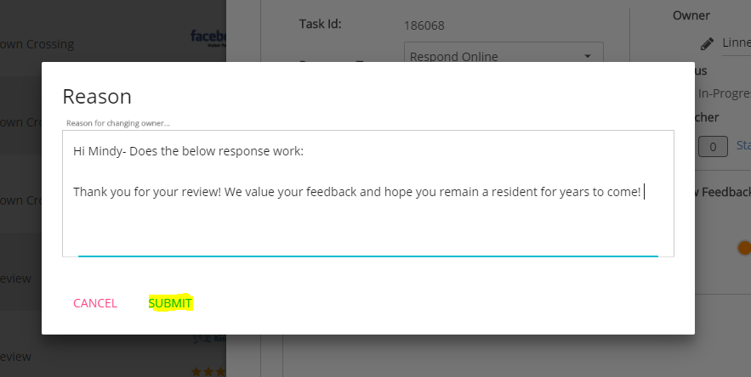

The tasks notes will display in the email alert and will also display in the activity detail icon at the top right of the task (highlighted below):

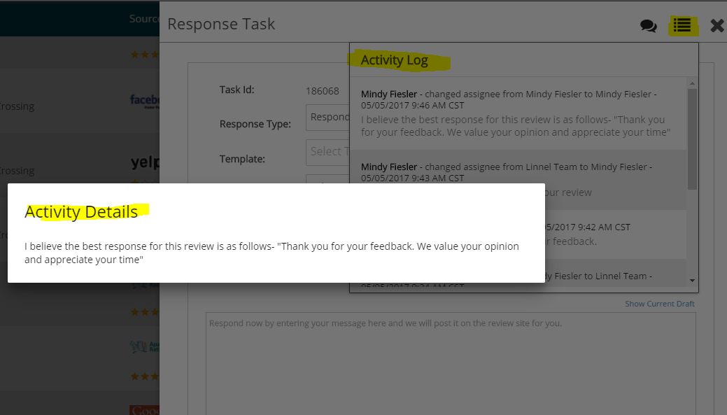

Linnell Taylor will then populate the approved message into the message box on the task, and hit “Submit” to respond online! This will close the task.