Essex Image Library guide

The Essex Image Library contains all of your community’s recent photography, as well as a selection of older photography. From the library, you can search, view and download photos for use on Craigslist ads.

Email marketing@essex.com if you need to access high-resolution or older images of your property.

**Access and download instructions**

1. Go to <http://essex.photoshelter.com/gallery-collection/Properties/C0000i1MEeOUgix4>.
2. Select your community’s region (Northern California, Southern California or Washington).
3. Find and then click on your community’s name (communities are sorted alphabetically).
4. Click the “Batch Download” button on the upper right side of the screen.

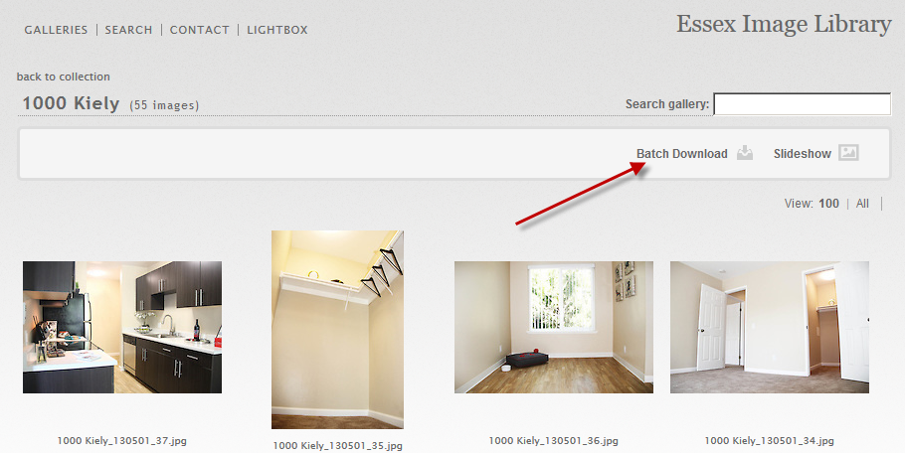

Note: You may be asked to provide a password. If so, enter **Property**.

1. Select one or more images you wish to download to your computer (select multiple photos by holding down the Shift key), then click “Continue.”

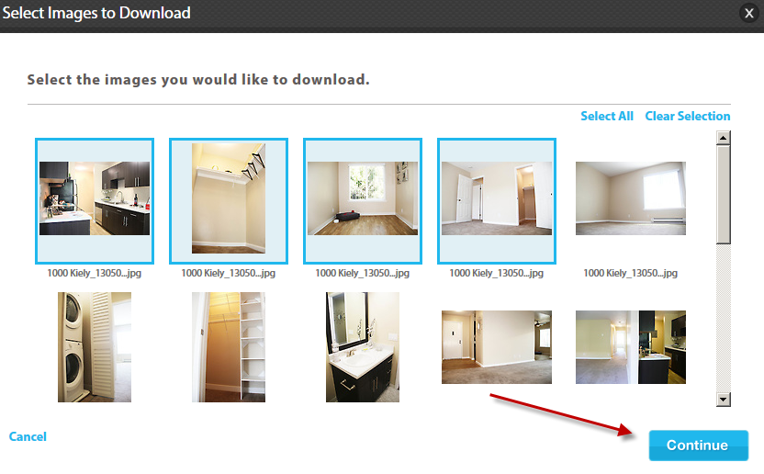

1. Choose the download size. If you will be using these images in your Craigslist ads, select the “Small” size. Click “Continue.”

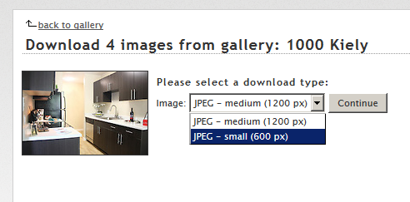

Note: If you choose the “Medium” size, Craigslist will resize it to the “Small” dimensions when you add your images).

1. Click the link provided to download the photos: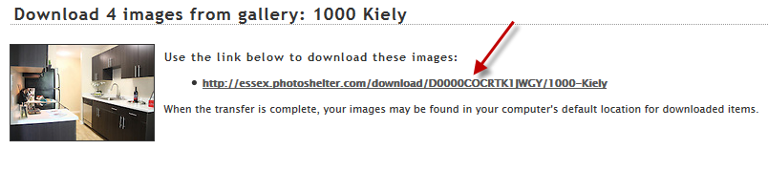

The files will be downloaded to your computer. If you selected more than one image, a zip file will be downloaded and you will need to extract the images to use them.