|  |  |  |  |  |  |  |
| --- | --- | --- | --- | --- | --- | --- |
| **Updated**  **2/9/22** | **Description** | **Properties Impacted** | **Dates** | **New Lease Actions** | **Renewal Actions** | **Additional Resources** |
| **AB1482** | Tenant Protection Act of 2019.  Limits rent increases to 5% + CPI,  not to exceed a total of 10%, in any 12-month period after initial  lease term.  *(CPI = Consumer Price Index, updated March/April each year for each region)* | All California Communities with Certificate of Occupancy issued prior to 2006 not regulated by stricter local rent control or affordable/BMR program. (126 CA Communities older than 2006; 47 CA communities not regulated by stricter local rent control or affordable program). | Effective 1/1/2020 | None - Vacancy Decontrol is Applicable | All renewal term offers capped at 5%+CPI.  Feature included in Atlas to maintain compliance on the max allowable increase and cumulative number of increases within a 12-month period. | [AB1482 Reference Materials](https://essexpropertytrust.sharepoint.com/:f:/s/rmd-revenuemanagers/EmgJvsLOiYlOjFyDOBU8lSsBotbJDu38tXlc_S3R-F1aSQ?e=cdMKzV) |
| **AB1110** | Rent Increases: Noticing.  This bill requires 90 days' notice if a landlord of a residential dwelling with a month-to-month tenancy increases the gross rent by more than 10% of the amount of the rent charged to a tenant annually. | All California Communities Not Subject to AB1482 or AB1919  (55 Communities) | Effective 1/1/2020 | None - Pertains to MTM Only | MTM offers are capped at a 10% gross rent increase for CA Communities not under AB1482 or AB1119. Notice period 35-55 days. | [AB1110 Supplemental Materials](https://essexpropertytrust.sharepoint.com/:f:/s/rmd-revenuemanagers/EiPmbaW1YsFMlnHh6ykUlkcBdbZ2kKRle6sQIoChvJG7Aw?e=LEcWpH) |
| **Ordinance No. 2021-20** | A temporary prohibition on certain evictions in Contra Costa County and a moratorium on rent increases for in place residents. | All properties in Contra Costa County | Effective June 22, 2021, through TBD | None | All renewals terms 1 through 12 are capped at the residents in place rent. |  |
| **LA County Rent Stabilization Ordinance** | A max allowable rent increase on an annual basis as determined by average CPI.  A temporary rent freeze on RSO buildings in Unincorporated Los Angeles. | Any property built before 2/1/95 in unincorporated LA.   1. The Promenade at Marina City club. | RSO Program -Effective 4/1/20.  Rent Freeze: 3/4/20 – 5/31/22 (tentative) | No effect to new leases. | Subject to max allowable increase as determined by average CPI.  Subject to LA unincorporated county rent freeze. | [LA County RSO Ordinance](https://dcba.lacounty.gov/noevictions/) |
| **City of Los Angeles Rent Stabilization Ordinance** | A max allowable rent increase on an annual basis as determined by Regional CPI, but not less 3% or greater than 8%. | Properties in LA city built before 10/1/78 or replacement units.   1. Skye at Bunker Hill. 2. The Blake LA. 3. Avondale at Warner Center | None. | No effect to new leases. | Renewals are capped at 4%. | <https://housing.lacity.org/residents/rso-overview> |
| **Mountain View Rent Stabilization Ordinance** | A max allowable rent increase on an annual basis as determined by 100% of CPI for SF-Oak-SJ region, except that the amount cannot be less than 2% or more than 5%. | Properties in Mountain view built before 2/1/95.   1. Regency at Mountain View. | RSO Program -Effective 2016. | No effect to new leases. | Renewals are capped at 3.5%. | <https://www.mountainview.gov/depts/comdev/preservation/rentstabilization/default.asp> |
| **San Francisco Rent Stabilization Ordinance** | A max allowable rent increase on an annual basis as determined by 60% of regional CPI. | Properties in San Francisco built before 6/13/79.   1. Fox Plaza Apartments 2. Park West | RSO Program -Effective 1979. | No effect to new leases. | Renewals are capped at 2.6%. | <https://sfrb.org/home> |
| **San Jose Rent Stabilization Ordinance** | A max allowable rent increase on an annual basis of 5%. | Properties in San Francisco built before 9/7/79.   1. Sage at Cupertino | RSO Program -Effective 1985. | No effect to new leases. | Renewals are capped at 5%. | <https://www.sanjoseca.gov/your-government/departments/housing/renters-apartment-owners/apartment-rent-ordinance> |
| **Hayward County Rent Stabilization Ordinance** | A max allowable rent increase on an annual basis of 5%. | Properties in  Hayward built before 7/1/79.   1. City View Apartments | RSO Program -Effective 1983. | No effect to new leases. | Renewals are capped at 5%. | <https://www.hayward-ca.gov/your-government/programs/residential-rent-stabilization> |
| **Santa Ana Rent Stabilization Ordinance** | A max allowable rent increase on an annual basis as determined by lower of 3% per year or 80% of the percent change in CPI over the previous 12 months. | Properties in Santa Ana built before 2/1/95.   1. Parkside Court 2. Fairhaven Apartment Homes | RSO Program -Effective 2021. | No effect to new leases. | Renewals are capped at Lower of 3% or 80% of CPI. | <https://www.santa-ana.org/rso> |
| **City of Glendale Rent Ordinance** | Glendale tenants forced out of their homes due to significant rent increases are entitled to relocation assistance where the rent increase is above 7%. | Properties built before 2/1/95.   1. The Henley | Effective 2018. | No effect to new leases. | Renewals are capped at a 7% increase. |  |
| [**Council Bill 119985**](https://seattle.legistar.com/LegislationDetail.aspx?ID=4068243&GUID=5E11FC67-94AD-435A-AC67-945192A34B22)**(Seattle)** | This legislation increases the minimum prior written notice that landlords in Seattle must give tenants before increasing their rent from 60 days to 180 days. | Seattle communities | Currently not signed into law by mayor. | No effect to new leases. | Provide renewals 180 days prior to the month the leases are expiring. | [PNW LAWS](https://essexpropertytrust.sharepoint.com/:f:/s/rmd-revenuemanagers/EirByXbuGgZGmjVByWuGtW8BbplsLO7z1BHxAoTzobz8Hg?e=MLDeBm) |
| [**Council Bill 120173**](https://seattle.legistar.com/LegislationDetail.aspx?ID=5134570&GUID=8ED73298-AD10-417B-B3DD-AB2BB2DCDAE7&FullText=1)**(Seattle)** | When they leave their current housing unit because the rent will increase ten percent or more. A landlord would be required to pay three times the amount of monthly housing costs per household for each moving household. | Seattle communities | Currently not signed into law by mayor. | No effect to new leases. | Provide renewals 180 days prior to the month the leases are expiring. | [PNW LAWS](https://essexpropertytrust.sharepoint.com/:f:/s/rmd-revenuemanagers/EirByXbuGgZGmjVByWuGtW8BbplsLO7z1BHxAoTzobz8Hg?e=MLDeBm) |
| **SF City Ordinance** | Ban on leasing corporate units. | San Francisco | April 1st 2020 | Ban on corporate leases in San Francisco. | We are not renewing corporate leases. | (Information provided soon) |
| **SF City Ordinance** | No short-term leases | San Francisco |  | No leases less than 12 month terms. Must apply for an exemption to avoid. Tenants can apply for a 12 month term and pay a lease break fee. | Only applies to new leases. | (Information provided soon) |

**AB1482: Tenant Protection Act of 2019 (California Properties Only)**

* 1. Effective January 1st, 2020 any property built with a Certificate of Occupancy issued PRIOR to January 1, 2005, and not regulated by stricter local rent control, affordable/BMR program, and or just cause ordinance, will be required to comply with the conditions of Assembly Bill 1482.

***Table A includes the Essex properties subjected to AB1482 on January 1, 2020.***

Supplemental reference materials sourced from the California Apartment Association AB1482 compliance page may be accessed here: [AB1482 Reference Materials](https://essexpropertytrust.sharepoint.com/:f:/s/rmd-revenuemanagers/EmgJvsLOiYlOjFyDOBU8lSsBotbJDu38tXlc_S3R-F1aSQ?e=cdMKzV)

**Key Components of the Tenant Protection Act of 2019 Pertaining to Allowable Rent Increases**

* Rent increases will be limited to 5% + CPI, not to exceed a total of 10%, in any 12-month period after the initial lease term.
* As per industry standards, “Rent” is defined as the monthly apartment rent excluding concessions. Other ancillary items (e.g. parking, storage.) are considered optional and outside of the rental rate used to calculate future increases.
* Renewal increases for ALL lease terms, including month-to-month, will be limited by the 5% + CPI cap.
* Rent cap provisions do not apply to a property that is subject to a local rent control ordinance that imposes a lower rent cap.
  + Table C specifies the Rent Control Rent Cap per CAA as of 11/1/19
* Allowable rent increases may be taken in two increments over a 12-month period through a “catch up” increase, but only if the lease has expired.
* Timing of Increase Example for “Catch Up” Increase: CPI of 3.5% and total increase cap of 8.5%.
  + Rent on 3/15/2020 is $2000 with an expiration date of 9/14/2020.
  + Rent increase applied on 9/15/2020 of 4% on a 3-month renewal; new rent is $2,080.
  + Rent increase allowed on 12/16/2020 for all lease terms is 4.5%; new rent can be $2,170.
* Rents will be reduced on January 1, 2020 for any resident that has received an increase above the maximum allowable amount. Resident rent as of March 15, 2019 will be used as the anchor rent for the CPI + 5% calculated rent cap.
  + While these adjustments may result in rent decrease for some residents effective January 1, 2020, it does not require a refund of “excess” rents that were paid during 2019.
* Vacancy decontrol is applicable; rents may be increased to market when a tenant vacates the unit.
* Existing and New Residents will be provided a written notice that contains a disclosure that will be included in lease agreement and lease renewal documents by August 1, 2020.
* Resident Notification (provided in no less than 12-point type):

*“California law limits the amount your rent can be increased. See Section 1947.12 of the Civil Code for more information. California law also provides that after all of the tenants have continuously and lawfully occupied the property for 12 months or more or at least one of the tenants has continuously and lawfully occupied the property for 24months or more, a landlord must provide a statement of cause in any notice to terminate a tenancy. See Section 1946.2 of the Civil Code for more information”*

**Essex Process Changes Effective January 1, 2020 for Properties Subject to AB1482:**

* Renewal letters will be issued 35-55 days in advance of the tenant lease expiration (vs. 65-80 previously) for all California properties.
* Renewal rent increases for ALL lease terms, including month-to-month, will be limited by the 5%+ CPI cap.
* Communities with multiple Certificate of Occupancy dates will follow the process for the earliest date of issue.
* Month-to-month offers will continue to be listed on the renewal letters with amounts set at the 5%+ CPI cap.
* Use of discounts, stale unit pricing and concessions on New Lease pricing will continue as necessary to remain competitive with the market.

**AB1110**

Requires that if a landlord of a residential dwelling with a month-to-month tenancy increases the rent by 10% or less of the amount of the rent charged to a tenant annually, as specified, the landlord shall provide at least 30 days’ notice, before the effective date of the change. If a landlord of a residential dwelling with a month-to-month tenancy increases the rent by more than 10% of the amount of the rent charged to a tenant annually, as specified, the landlord shall provide an additional 60 days’ notice, for a total of 90 days, before the effective date of the increase.

Supplemental reference materials sourced from the California Apartment Association AB1482 compliance page may be accessed here: [AB1110 Supplemental Materials](https://essexpropertytrust.sharepoint.com/:f:/s/rmd-revenuemanagers/EiPmbaW1YsFMlnHh6ykUlkcBdbZ2kKRle6sQIoChvJG7Aw?e=LEcWpH)

**Key Components of AB1110**

* Renewal increases less than 10% need to be sent out 30 days in advance.
* Renewal increases greater than 10% need to be sent out 90 days in advance.

**Essex Process Changes Effective January 1, 2020 for Properties Subject to AB1110:**

* Renewals will be capped at a max 10% increase for all Non-AB1482 communities.
* All renewals will be sent out to residents 35-55 days in advance of their expiration month.
  + I.e. November Renewals will be sent out to residents no later than the 25th of October.

[**Council Bill 119985**](https://seattle.legistar.com/LegislationDetail.aspx?ID=4068243&GUID=5E11FC67-94AD-435A-AC67-945192A34B22)**and** [**120173**](https://seattle.legistar.com/LegislationDetail.aspx?ID=5134570&GUID=8ED73298-AD10-417B-B3DD-AB2BB2DCDAE7&FullText=1)

Legislation that requires landlords to send out renewals to residents a minimum of 180 days in advance. If the landlord provides an increase greater than 10% and the resident determines it is not fair, the landlords are required to pay 3 times the monthly housing cost as moving expenses.

**Key Components:**

* Landlord has to provide renewal letters 180 days in advance.
* Increases of more than 10% have to pay 3 month’s rent to the tenant as relocation fees.

**Essex Process Changes**

* For renewals, provide notice to all Seattle Sites 6 month in advance with a max of 9.9%.
* For M-t-M residents, send out offers 6 months in advance with a 9.9% max increase.

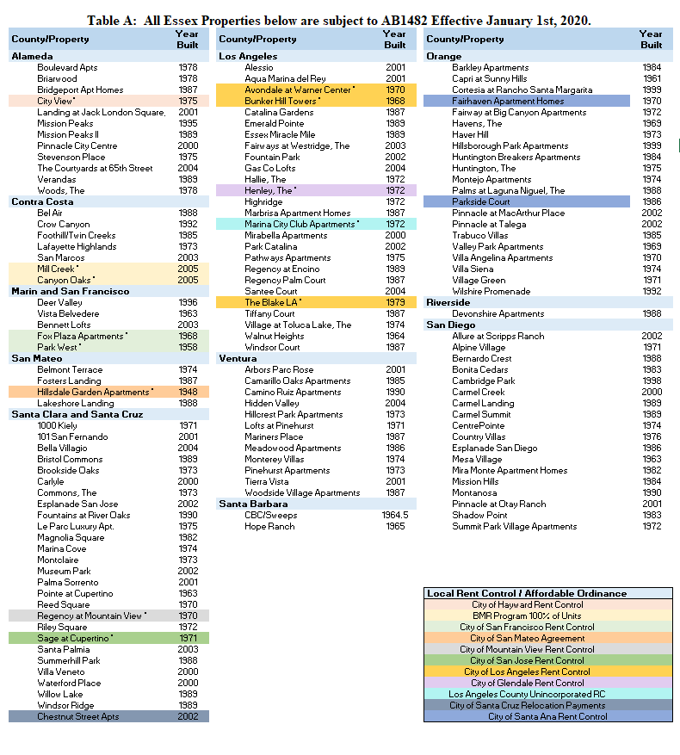4

