Community Name

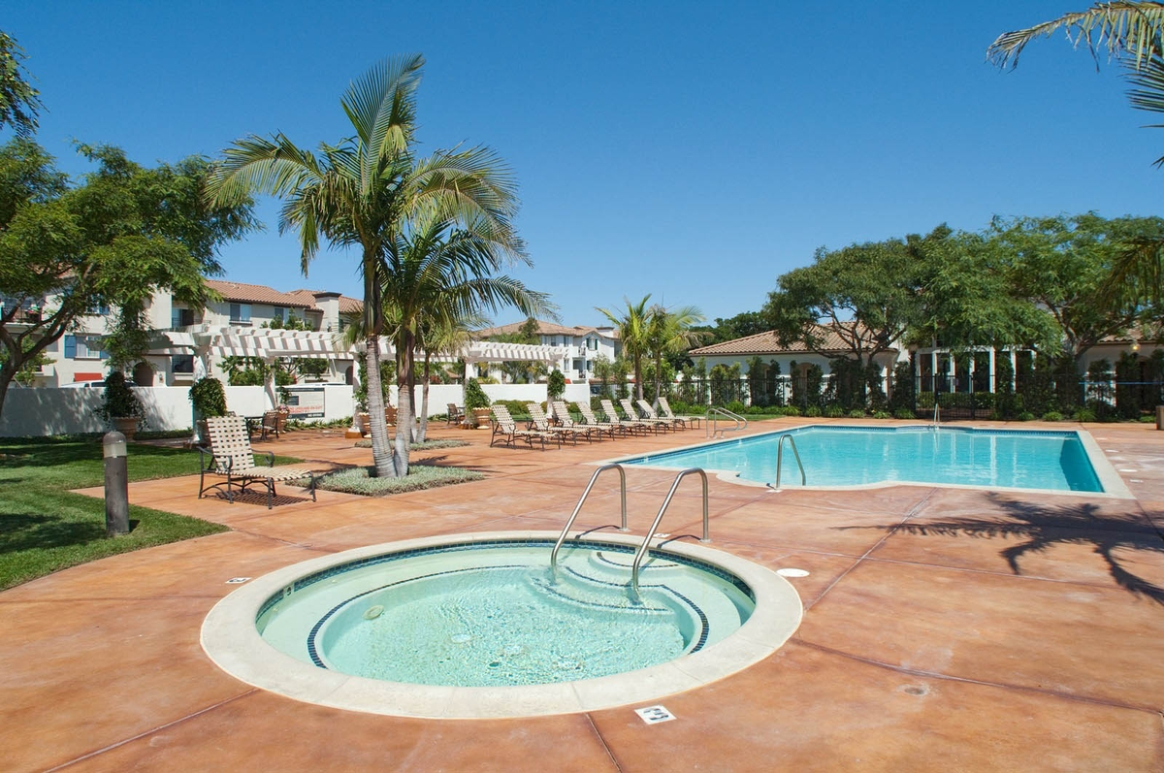

**Resident Newsletter :: MM/YY**

Mauris nonummy, turpis ac lacinia ultrices, ligula nisl tempor odio, eget viverra dolor massa at lacus. Donec ultrices arcu id massa. Pellentesque vel lectus. Sed at mauris. Nunc facilisis ipsum nec urna. Proin rhoncus, magna eu tristique condimentum, leo justo imperdiet odio, vehicula ultrices enim diam et nunc. Sed consequat ultricies nunc. Mauris nulla. Nam sem nisi, fringilla semper, tristique id, cursus vel, pede. Nunc lacus. feugiat.

**Headline**

**Mon., 11/15:** Neighborhood watch meeting in the clubhouse

**Wed., 11/17:** Resident brunch in the clubhouse

**Thurs., 11/18:** Resident party by the pool

## **Community Events**

“Give neither counsel nor salt till you are asked for it.”

– Italian proverb

**Quote of the Month**

## **Community Reminders**

Mauris nonummy, turpis ac lacinia ultrices, ligula nisl tempor odio, eget viverra dolor massa at lacus. Donec ultrices arcu id massa. Pellentesque vel lectus. Sed at mauris. Nunc facilisis ipsum nec urna. Proin rhoncus.