**Funnel**

**Community Knowledge Base**

**Guide to Making Updates**

# **Table of Contents**

Table of Contents pg. 1

Overview pg. 2

Overview Tab pg.3-4

Maintenance pg.5

Neighborhood pg.5

Leasing pg.6

Pet/Utilities pg.7

Floor Plans pg.8

W/D & Parking pg.9

Appointment pg.10-11

Sister Communities pg.12

# **Overview**

All information listed in Funnel will be visible by The Contact Center and Site Teams as the agent’s sole source of information to educate prospects about your community. It is crucial that the information entered in Funnel is accurate and up-to-date. The information contained in this application is ingested from many sources however, there are also several places in the application where you may directly edit information about your community. Please direct questions about updating Funnel to [ContactCenterSupport@Essex.com](mailto:ContactCenterSupport@Essex.com).

# Support:

All support inquires (escalations, feedback, concerns, etc.) MUST be sent to [ContactCenterSupport@Essex.com](mailto:ContactCenterSupport@Essex.com) and will be responded to within 2 business days.

*High priority escalations should also CC* [*JoFlores@Essex.com*](mailto:JoFlores@Essex.com)*.*

# Community Managed Fields

The below fields are managed directly by the Community Manager of each site. For any changes, please follow the corresponding process below. Please review all information as this will be the source of truth when providing information for prospects.

* Community name
* Public description
* Apartment selling points
* Floor Plan (Notes section)
* Utility Companies / Paid utilities / Utility Fees
* Affordable housing
* Maintenance (On call/emergency numbers and notes section)
* Appointments (Tour notes section)

# Marketing Managed Fields

The below fields are managed directly by the Marketing Team. For any change requests for these areas, email: [**Marketing@Essex.com**](mailto:Marketing@Essex.com)**.** All requests will be responded to within **3 business days.**

* Deposit, Terms, and Fees
* Sister communities
* Neighborhood
* Contact Information
* Property selling points
* Community selling point

# Contact Center Managed Fields

The below fields are managed by the Contact Center Team. Please follow the listed process to request any changes.

* Touring parameter
* Office hours

# **Overview Tab**

Information areas highlighted in red can get updated by emailing [Marketing@Essex.com](mailto:Marketing@Essex.com). Please allow 3 business days for a response. C**ombine all edit requests to Marketing and send as a single email.**

* **Contact**: Pulled from yardi
  + Email [ContactCenterSupport@Essex.com](mailto:ContactCenterSupport@Essex.com) for changes
* **Office Hours**: Pulled from Yardi
  + Follow
* **Floor Plans**: Starting price is pulled from current pricing listed in Rentcafe. For pricing inquiries please refer to the “Pricing and Availability” job aid on Buzz (Property Operations > Marketing > Internet Marketing Resources > Community Website > Pricing and Availability)

For additional questions please email [RevenueManagement@Essex.com](mailto:RevenueManagement@Essex.com)

* **Building Info**: Pre-Entered
* **Special Offers**: Updated automatically when specials are added to the community webpage
* **Property Summary**: This information pulls from each community’s summary on Essexapartmenthomes.com
  + Reach out to [Marketing@essex.com](mailto:Marketing@essex.com) for any changes
* **Apartment Features & Community Amenities** 
  + All Features & Amenities have been recently standardized. Any change request for these areas need to be sent to [Marketing@Essex.com](mailto:Marketing@Essex.com). **Please allow for 3 business days for a response**
* **Property**
* Information in this area is currently not editable and will be available for the edits at a later date.

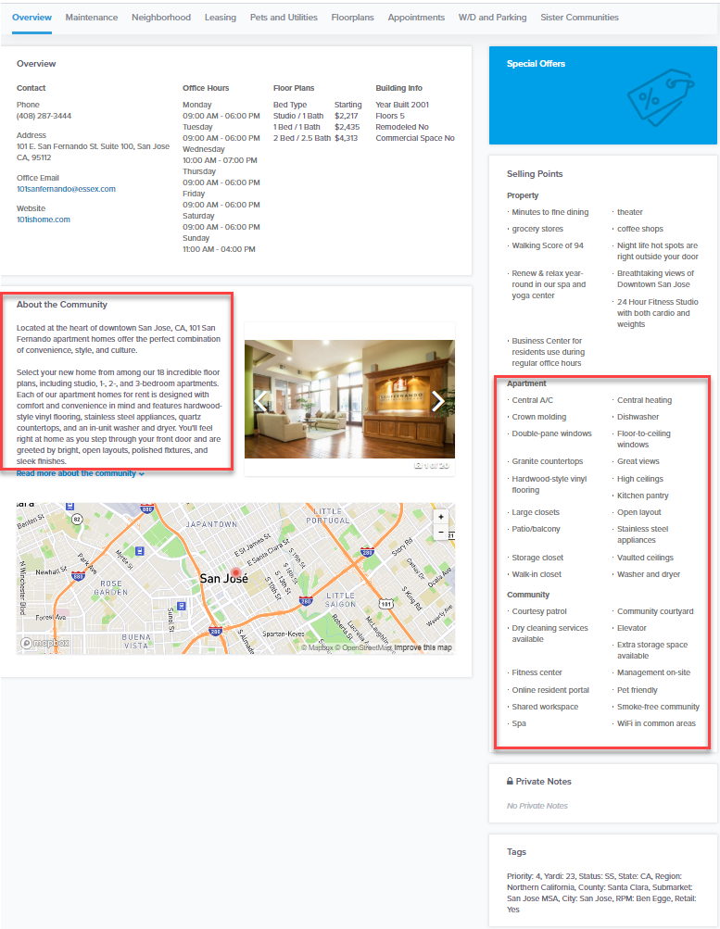

# **Overview: Private Notes**

Notes listed in this area will include any community specific information you need the Cotnact Center Team to be aware of. Please make sure to date stamp all notes and remove notes if they are no longer

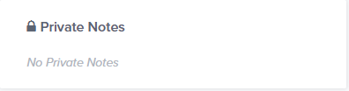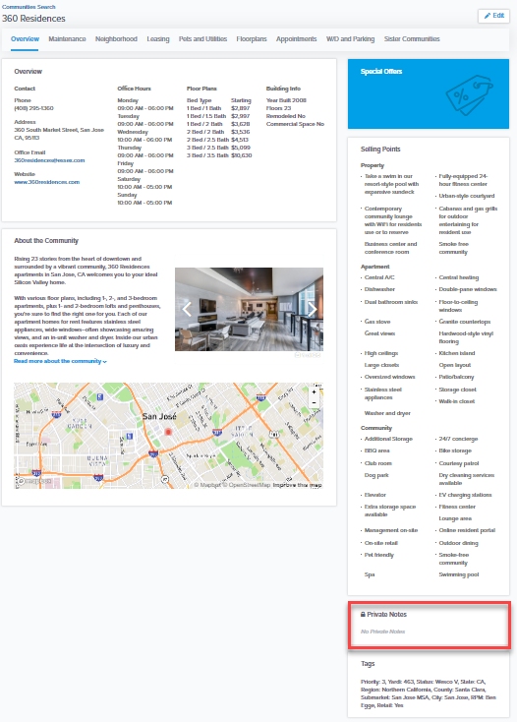

To update the “Private Notes” are, click “Edit” in the top right-hand corner of the page

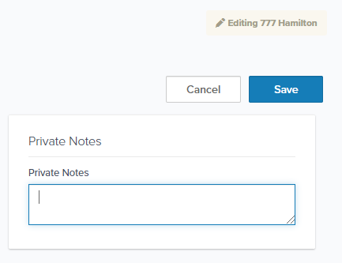

Once you click “Edit” the edit window will pop up. “Private Notes” will be in the top right-hand corner. Click “Save” to ensure updated note is published.

# **Maintenance**

All after hours maintenance processes are currently being transferred to Sight Plan. The “Maintenance” tab will no longer be editable and all listed information will be removed. For any Sight Plan support questions please email [Help@SightPlan.com](mailto:Help@SightPlan.com).

For any Sight Plan concerns and/or feedback please reach out to [CTrindell@Essex.com](mailto:CTrindell@Essex.com)

# E-Way process for Sight Plan

<https://us.promapp.com/essex/Process/Minimode/Permalink/u5ZP4m0DUciGkcCyzt6fJ>

# **Neighborhood**

Any change requests must be submitted to [Marketing@Essex.com](mailto:Marketing@Essex.com). Please allow 3 business days for a response. **Please combine all edit requests to Marketing and send as a single email.**

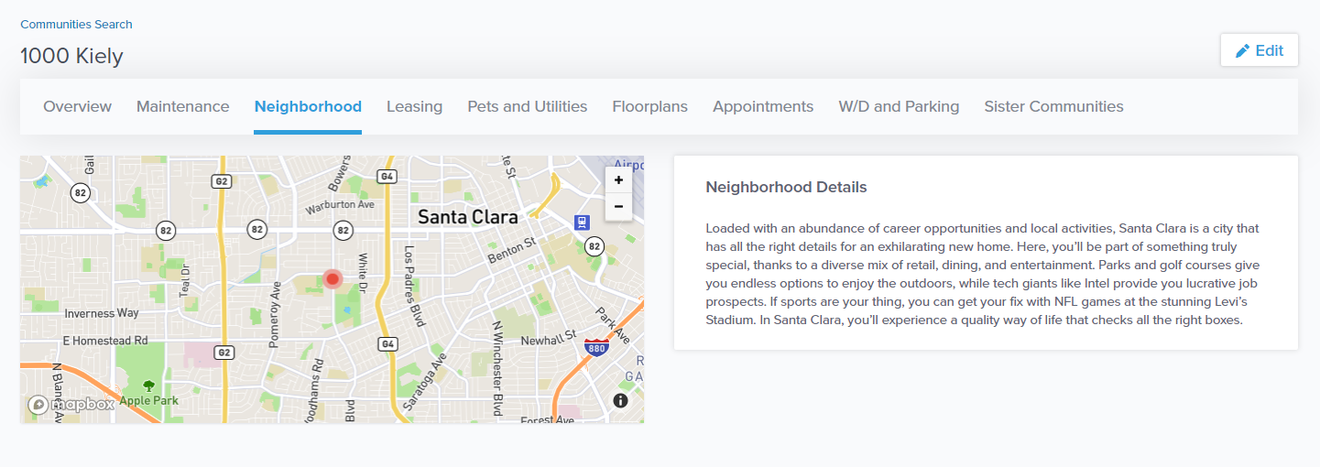

# **Leasing**

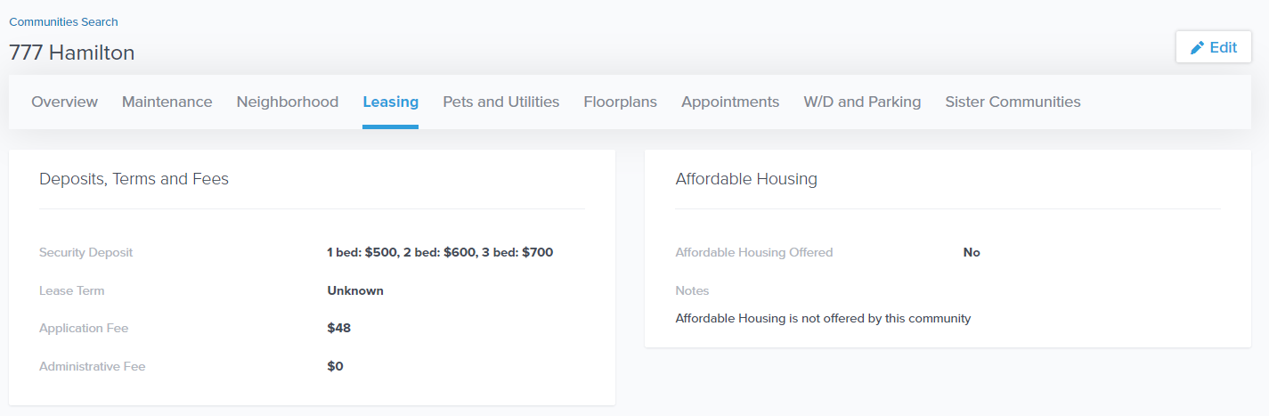

# Deposits, Terms, and Fees

This area is managed by the Marketing Team. All change requests need to be sent to [Marketing@Essex.com](mailto:Marketing@Essex.com) with **RPM approval**. Please combine all edit requests to Marketing in a single email.

# Affordable Housing

Notes section can be updated by clicking “Edit” in the top right-hand corner. Once the notes are updated, click “Save” in the top-right hand corner.

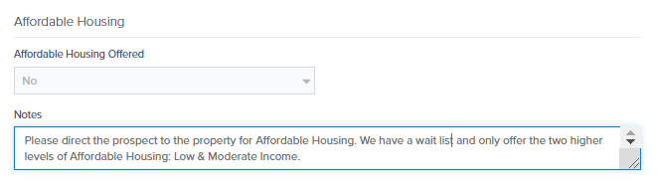

# **Pets/Utilities**

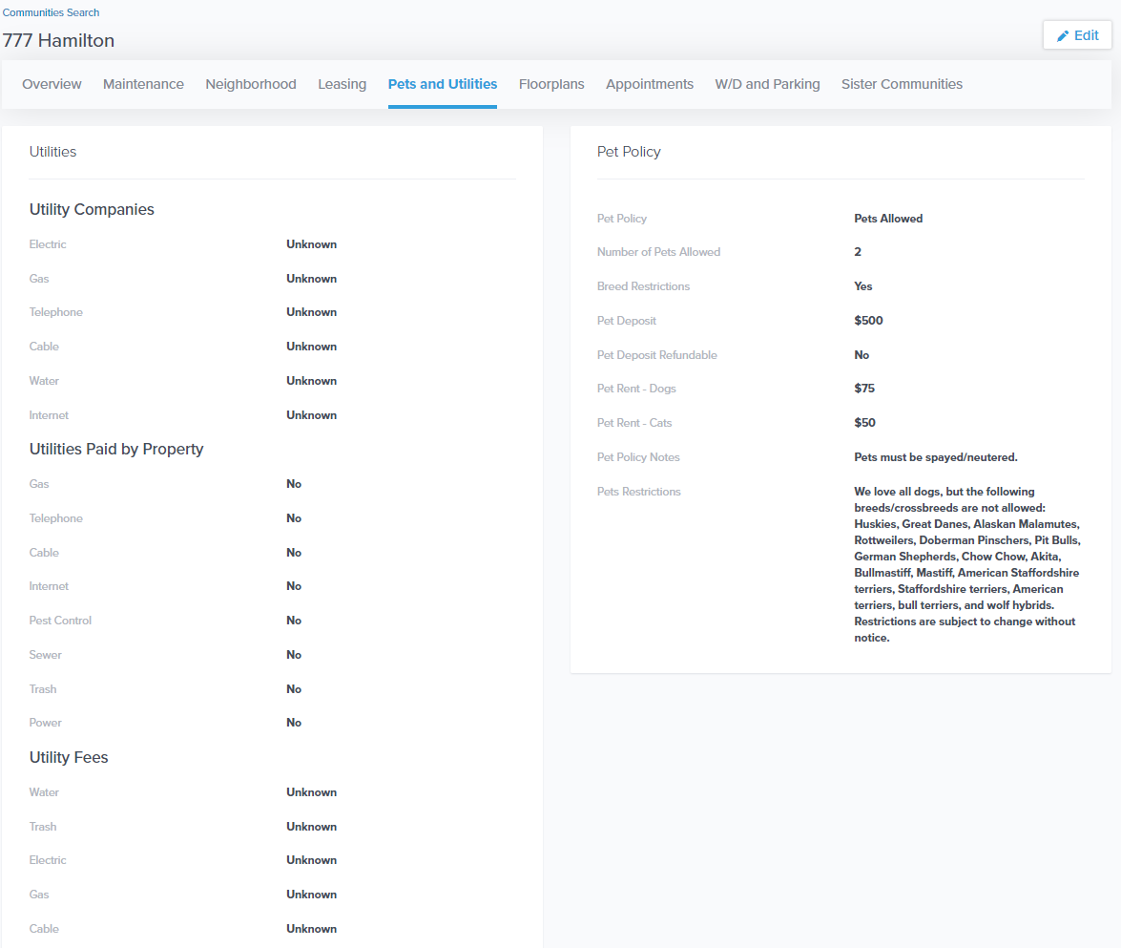

# PET POLICY

Information in this area is currently not editable and will be available for the edits at a later date.

# Utilities

Information in this area is currently not editable and will be available for the edits at a later date.

# **Floor Plans**

# 

# Notes

***All notes in this field MUST be updated/deleted as soon as offer dates change***

Notes in this area can be updated by clicking “Edit” in the top right-hand corner of the page. Once notes are updated in this area, click “Save” in the top right-hand corner of the page.

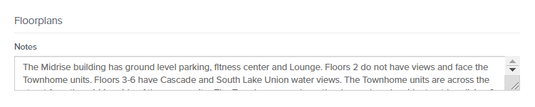

# Site Maps

All Site Maps have been consolidated and uploaded to Funnel for you. If any changes are made to your site map, email [ContactCenterSupport@Essex.com](mailto:ContactCenterSupport@Essex.com) with the updated version.

# **W/D and Parking**

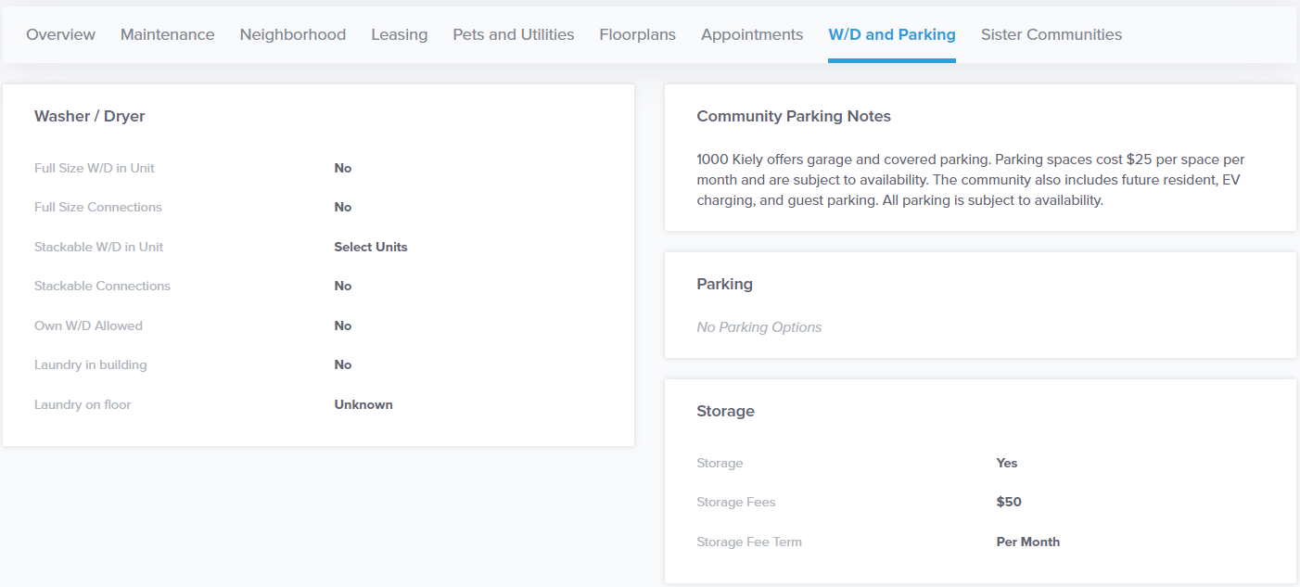

# Washer/Dryer

Information in this area is currently not editable and will be available for the edits at a later date.

# Community Parking Notes

Parking paragraphs have been created to be utilized by the Contact Center team when providing parking information for prospects. A parking initiative is currently under way to get all areas of parking updated in this area for all communities; These changes will be completed by Q2 of 2020. Until then, information in this area will not be editable.

# **Appointment**

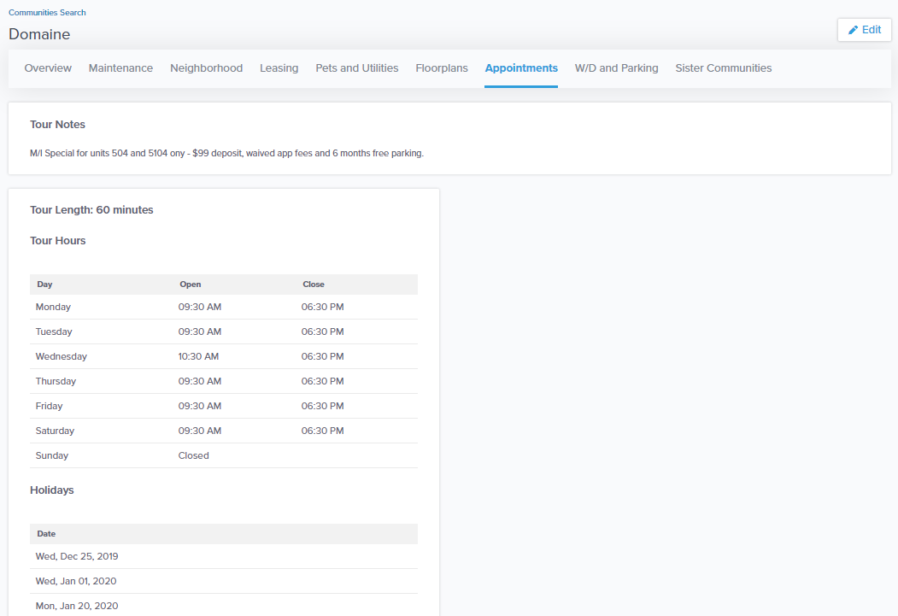

# Tour Notes

Can be edited by clicking “Edit” button on the right-hand side of the screen and scrolling down to the bottom of the screen. Once notes are updated click “Save” in the top right-hand corner

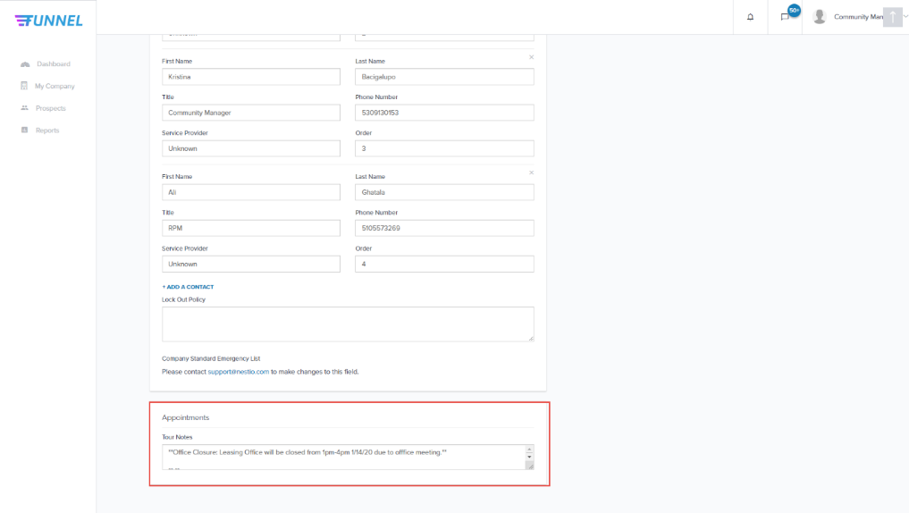

# Tour Length & Touring Parameters

These fields are managed by Contact Center Support for all communities. Please refer to the “Touring Parameters” document on Buzz (Property Operations > Contact Center > Job Aids (Right Side) > Updating Office Horus & Touring Parameters).

For any change requests to your communities touring parameters, please email [ContactCenterSupport@Essex.com](mailto:ContactCenterSupport@Essex.com) and include approval from your **DM/VP.**

# Holiday & Office Closure Dates

This area includes all your community’s holidays, the company picnics, and the company galas as listed on Buzz. Any requests outside of the corporate approved holidays need to be sent directly to [Contactcentersupport@Essex.com](mailto:Contactcentersupport@Essex.com) with **DM/VP approval**.

Sister Communities

This content mirrors what’s listed on the Essex community webpage

